Setting up raw disks for ASM on a cloned Linux VM

In general, disks are considered “raw” when they are not mounted to a file system but accessed directly. A disk is “cooked” when mounted to a file system.

The primary task, once the OS is running, will be to change the raw disk device names and all of the links that are tied to the disks. The cloning does not carry over the changed disk device names. This will need to be done so the application/database will see the disks properly. Refer back to the original system to see how it should look.

The screenshots below show an abbreviated listing. They were taken from nrc3lperf2db02vm.

1. Clone the Linux image in the usual manner.
2. Bring up the new VM client. Change the hostname and IP as needed.
3. Change the disk device names. Change to the /dev directory and you will see devices with sd? names. For example, you will see sdh and sdh1. The device with the 1 at the end is the one that will need to be changed. Look on the original system to see the names. They are usually asm-data, asm-grid, asm-index, etc. You may need to look under /dev/disk/by-path on the original system to figure out which asm name goes with which sd?1 device.
   1. The cloning process should bring over the disks so the device with the same name should be the same size. So if sdh1 was 100GB on the original system it should be 100GB on the clone. One way to verify that is with the *fdisk -l* command. The command *fdisk -l /dev/sdh* should give the same results on both systems.
   2. Change the sd?1 name with the *mv* command. Note new name for each sd?1 device.
   3. 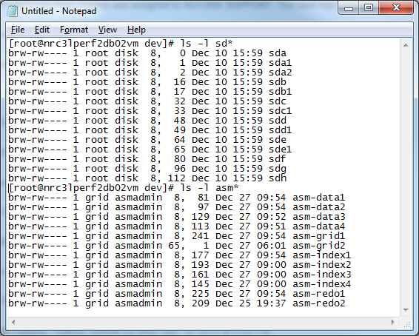
   4. Change the owner and group of the asm\* devices. In this case it is grid as the owner and asmadmin as the group. Use the original system as a reference.
4. Change the corresponding links to the /dev/asm\* devices. There are two places this will need to be done.
   1. Move to the /dev/disk/by-path directory. Do *ls -l* of the directory. You will see links to the /dev or ../../ directory. You will note that some links to sd?1 devices will be blinking. Those are the “broken” links that will need to be changed.
   2. Note the link name you will be changing. It will start with ‘pci-0000:” Remove the “broken” link. Create the link to the new link to the new device name. Again, refer to the original system as a guide.
   3. 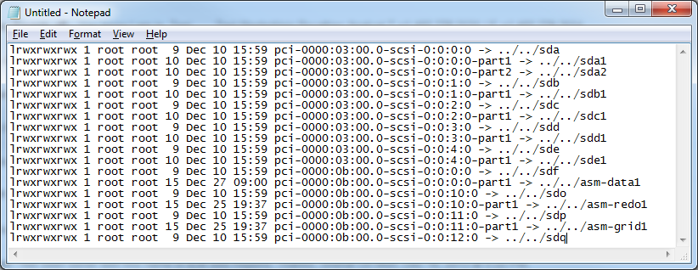
   4. Move to the /dev/disk/by-id directory and make the same changes as in the by-path directory. Note that there are actually two links for each device that needs to be changed. One starts with scsi and the other starts with wwn. They have the word part1 in the name.
   5. 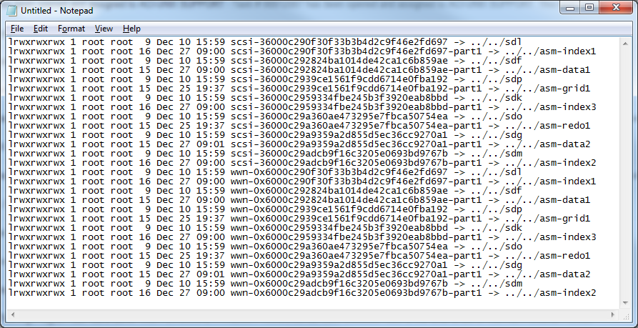
   6. I suggest doing 2 or 3 links then checking with the *ls -l* command and comparing to the original system to make sure all the links are aligned with the right devices.
5. In the /etc/udev/rules.d directory there may be a file that begins with 99-oracle-asmdevices or similar. Check that file for references to asm devices. You will see “NAME=asm-data1”. Just before that in the same line, is a “RESULT” entry. Compare the entries in the file with the links under the /dev/disk/by-id directory. Change the “RESULT” entry as needed. It will be the long ID number as shown in the above example.
6. Have the DBA test connecting to the disks. If all is successful, the data should be on the disks and the database should be able to start.